International Journal of Civil
Engineering (IJCE)
ISSN (P): 2278-9987; ISSN (E): 2278-9995
Vol. 8, Issue 4, Jun - Jul 2019; 21-32
© IASET
SPEECH INTELLIGIBILITY ASSESSMENT AT ARCHITECTURE JURY ROOMS IN DHAKA
Sheikh Rishad Ahmmad¹ & Jayedi Aman²
¹Lecturer, Department of Architecture, Ahsanullah University of Science and Technology, Tejgaon, Dhaka, Bangladesh
²Assistant Professor, Southeast University, Tejgaon, Dhaka, Bangladesh

ABSTRACT
Speech intelligibility, the percentage of speech that a listener can understand is a prime factor during the architecture jury session. The paper analyses the acoustical quality of Jury rooms in the capital city of Bangladesh- Dhaka to recommend an achievable sonic environment for the design presentations. Jury room of Architecture department in Ahsanullah University of Science & Technology (AUST) has been selected as the case jury room to test the quality of speech intelligibility in two phases: Existing designed case room and Redesigned case room,by measuring the independent variables such as reverberation time, the percentage of syllable articulation and sound-to-noise ratio. The finding reveals that the existing situation is very much affected by the lack of sound diffusion all over the place and inappropriate sound pressure level, while the condition has been improved after redesigning the waffle ceiling. Finally, the study will recommend a recommendation for effective distribution of speech intelligibility in the internal space of the jury room.

KEYWORDS: Jury Room, Reverberation Time (RT), Diffusion of Sound, Sound-To-Noise Ratio (SNR), Sound Pressure Level

Article History
Received: 12 May 2019 | Revised: 31 May 2019 | Accepted: 12 Jun 2019

INTRODUCTION
Jury rooms are primarily used to present the student’s project works in front of the jurors and visitors. During the jury session, everyone in the room rightfully expects to understand every single word uttered by the presenter and jurors. Therefore, one of the most important factors is speech intelligibility to provide a feasible teaching/learning environment. In the absence of sound amplification or electric aid, the larger the jury room space is, the more effort the presenter must exert in order to make himself understood in every part of the room, particularly the remote sites (Kinsler, 2000). Consequently, the visitors/students are also expected to strain their ears to hear the presentation and the comments (De-Chiara, 2001).
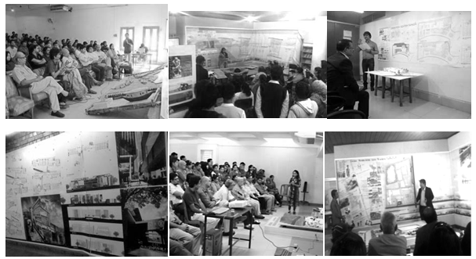
F

igure 1: Jury Rooms of the Architecture Departments Located at Different Universities in Bangladesh
Unfortunately, in Bangladesh designing a jury room concerns a very little in solving the acoustical problems for the particular activities (Figure 01). For that reason, inappropriate distribution of sound all over the room creates poor intelligibility of speech which results in the visitors’ and jurors’ lack of concentration towards the presentation. In most of the cases, especially in the rear rows, visitors continue to discuss between themselves, which creates excessive ambient noise into the room. On the other hand, good acoustical design in the room deals with the origin, propagation and auditory sensation of sound, sets optimum conditions for producing and listening to speech (Pumnia,2005) and consequently, appropriately designed teaching/learning environment acoustically creates the learning space more lively and then the speech intelligibility will be properly obtained.
To achieve this aim, the following objective has been developed.
- To predict the acoustical problems associated with the factors affecting speech intelligibility in the architecture jury rooms.
- To find out the best possible recommendation regarding the interior wall and ceiling design for ensuring the proper speech intelligibility during the jury session.

The first part of this paper focuses on the selection of a suitable case jury room for examining the present acoustical condition. Then, the room was analyzed by environment measurement instruments such as sound meters to measure the factor readings. Finally, an experimental ceiling design was provided and wall panel was recommended to provide a feasible sonic environment in the jury room.
It is expected that this paper will help designers to comprehend the significance of proper acoustical quality in architecture jury rooms considering the proper sonic environment which will not only reduce the pressure on energy demand such as electrical aids but also improve the occupants’ health condition.
Factors Affecting the Speech Intelligibility
Rooms such as classroom/jury room are intended for speech communication between the teachers and students (Amasuomo, 2013) and jury room serves the same purpose, where the presenter/student presents and jurors throw their opinion by verbal communication. The negative effect of poor intelligibility is more obvious when listening in a second language (Generally English, whether the first language is Bengali) in which the audience is less able to use context to guess particular words (Bradley, 1986). The other factor is that the listeners with any hearing impairment will be more affected by inadequate acoustics and excessive noise, as well as the very young and very old listeners with normal hearing (Amasuomo, 2013). These groups are less capable of processing speech sounds to correctly determine their meanings. Therefore, jury room acoustic considerations for very old listeners should also be undertaken, so that they have equal access to the speech communication.
Reverberation Time (RT)
The reverberation time of a room is defined as the time required for the sound pressure level in a room to decrease by 60 dB after the sound is stopped, and is calculated by the formula:
RT= 0.16V/(A+V) ………………………………………… …………………………………………. (1)
Where RT= Reverberation time in second, V= Room Volume in cubic feet, A=Total room absorption in SqmSabins, x= air absorbent coefficient.
For speech, space should have relatively lower reverberation time. Generally, it covers a narrow range of frequency spectra in lower mid-level (about 170 to 4000 Hz, for an average dynamic range of 42 dB). The optimum RT for speech in the English language is 0.8 to 1.2 and the recommended optimum RT for the Bengali language ranges from 0.5s to 0.8s (BNBC, 2015).
Percentage of Syllable Articulation (PSA)
The percentage of meaningless syllables correctly written by listeners is called the Percentage of Syllable Articulation. In ideal condition (no, noise, speech level 75 dB), the minimum admissible PSA should be 75% for a satisfactory Speech Intelligibility (BNBC, 2015).

Sound Pressure Level
In a space with low background noise (<20 dB) and a minimum RT (close to 0.0 s), a maximum Percentage Syllable Articulation (PSA), and thus Speech Intelligibility can be achieved at a sound pressure level of speech ranging from 60 dB to 70 dB. For speech halls with higher background noise (>20 dB), the recommended SNR is +15 dB for children and at least +6 dB for adults.

Diffusion of Sound
Diffusion of sound should be achieved in any space, so that certain key acoustical properties, like sound pressure level, reverberation time, etc. are the same anywhere in the space. The difference between sound pressure levels of any two points in the audience area should not be greater than 6 dB(BNBC, 2015).
METHODOLOGY
This paper examines the acoustical condition during two time periods. First, the selected case jury room was analyzed through measuring RT and determining SNR calculating the sound pressure level and diffusion of sound to find out the existing condition of speech intelligibility. Then, the room was redesigned by placing vertical panels in the hollow spaces of the waffle ceiling and measured through the same perimeters to analyze the differences between the two situations.

Case Jury Room Selection
In Bangladesh, there are 22 universities with an architecture department and among these universities, 14 are located in Dhaka (Aman & Joarder, 2017). Most of the listed universities in Dhaka have designed or renovated architecture jury rooms. One jury room is needed to be selected as ‘case jury room’ on which the performance of speech intelligibility will be tested. The criteria for the selection of the case jury room were based on the following factors (Aman & Joarder, 2017).

- Location of the university would be in the urban context of Dhaka.
- The jury room must be located on a designed and planned campus.
- Year of completion of the building should be within the last 10 years (2007-2017).
- Jury room should be designated and designed mainly for jury purpose.
- The activity pattern and internal layout of the room should represent the current practice of architecture jury rooms of Bangladesh.
Considering the mentioned criteria, the jury room at the Department of Architecture, Ahsanullah University of Science and Technology (AUST) was chosen as the case jury room. The academic building of AUST is an example of contemporary Architecture, which was built in 2008 (Figure 2). The university is located in the Tejgaon industrial area, having a frontage road of 8m in width and main entry from the west (Figure 3).
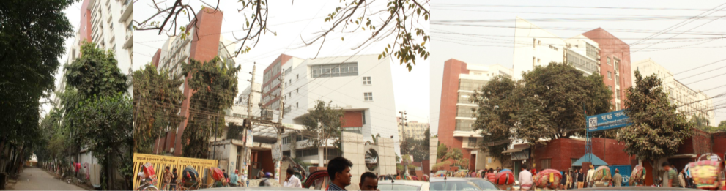
Figure 2: View of AUST
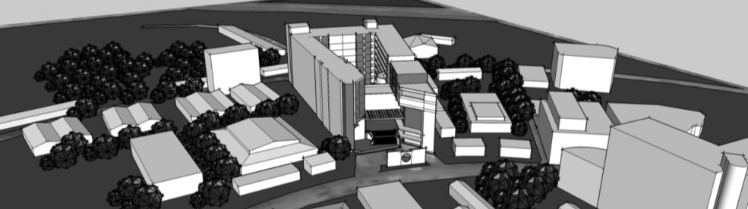
Figure 3: The Surrounding Context of AUST
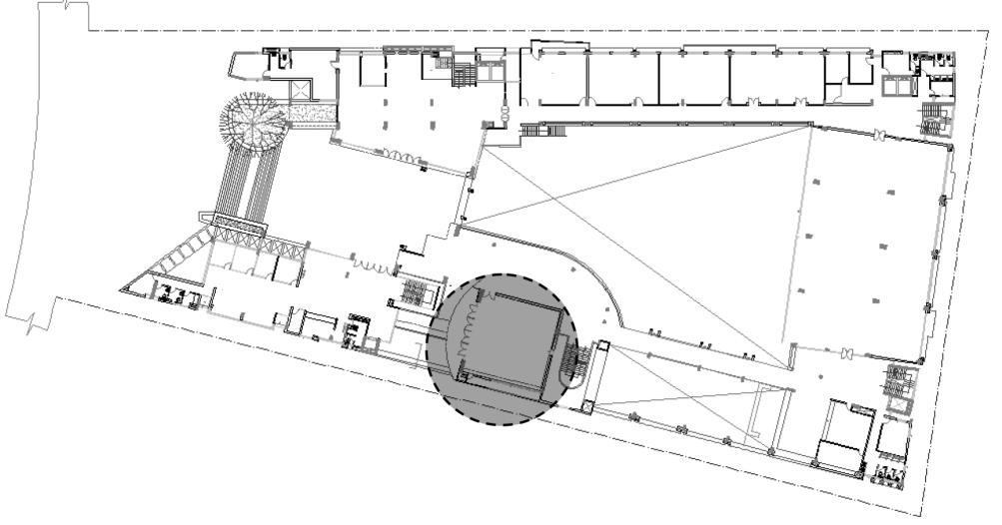
Figure 4: 1st -Floor Plan of AUST, Indicating the Architecture Jury Room
Among four main blocks of the building, the architecture department is located at 1st to the 4th floor of the south block. Architecture jury room, located on the first floor, is a square-shaped room (11.8m x 11.3m) (Figure 4). The outer view of the case jury room is shown in Figure 5.
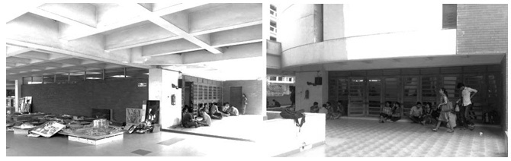

Figure 5: Outer View of the Case Jury Room

Properties of the Architecture Jury Room

West façade: Eight doors; materials: glass and wood; door height: 2.45m, door width: 0.75m.
East façade: Single slit vertical window; material: transparent glass with an aluminum frame; the height of the window: 3.5m with drop beam.
North façade: One high window; material: transparent glass with aluminum frame.
South façade: One high window; material: transparent glass with an aluminum frame; sill height: 2.45m; lintel height: 3.5m.
Floor Area of the jury room: 133.3 Sqm; clear height with a ceiling of the jury room: 3.5m.
Floor Material: 600mm x 600mm glazed tiles.
Ceiling: Waffle structured, made of concrete, white plastered.

Field Study and Results
The survey was conducted by a team of 19 student volunteers and 2 researchers. According to the field survey, the major problem regarding the speech intelligibility was found due to moderately high reverberation time, incongruous sound pressure level and lack of sound diffusion, especially in the Bengali language. To improve the situation and to make the comfortable sonic environment, wall and ceiling design were proposed.
Calculation of RT
During the jury session, the jurors generally seat of the chairs, while thestudents seat or stand behind the jurors to observe the jury. In the case room, it was found that, about 50-75 observers remain present during the session. Therefore, the occupants were considered as 75 persons at a time in the room for the study. Information about the case jury room was collected from the design consulting firm (Riddhi Architects, Dhaka) and architectural construction drawings were used to measure the variables by calculating the properties and dimensions of the materials. Figure 6 presents the interior view of the existing case jury room, while the section of the room shows the material properties and dimensions (Figure 7), which was used to calculate the Reverberation time.
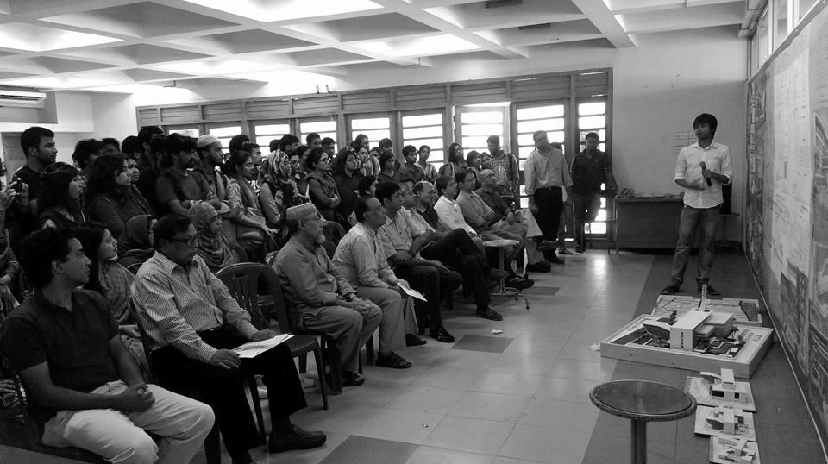
Figure 6: Interior View of Existing Case Jury Room
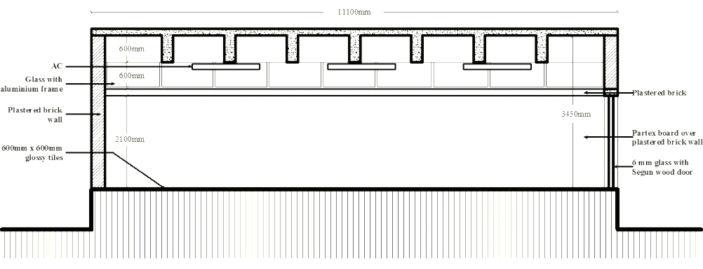
Figure 7: Section of the Case Jury Room
To estimate the Reverberation Time, the volume of the room was measured through the length, width, and height. Moreover, the absorption coefficient values of the materials were calculated through the total usable area of the materials, used in the case room. Finally, the RT was calculated using the formula (1), found in the literature.
Table 1: Calculation of RT for the Case Jury Room

Sl. No. | Surface | Material | Area |  |  | Ab. Coef. | Total Ab.
 |  |  | Length | Width | Sqm | Α1000 | Sα
1 | Floor | Glazed Tiles | 11.1 | 11.8 | 130.98 | 0.01 | 1.31
2 | West Wall | Brick wall plastered | 7 | 3.5 | 24.5 | 0.02 | 0.49
 |  | 6mm Transparent glass | 1.8 | 14.4 | 25.92 | 0.03 | 0.78
 |  | Barma-Teak Wood | 40 | 0.15 | 6 | 0.07 | 0.42
3 | East Wall | Brick wall plastered | 11.8 | 1.2 | 14.16 | 0.02 | 0.28
 |  | 6mm Transparent glass | 1.8 | 1 | 1.8 | 0.03 | 0.05
4 | South Wall | 12mm Ply Board over brick wall | 11.1 | 2 | 22.2 | 0.09 | 2.00
 |  | 6mm Transparent glass | 7 | 1.2 | 8.4 | 0.03 | 0.25
 |  | Brick wall plastered | 5 | 1.2 | 6 | 0.02 | 0.12
 |  | Wood | 2.1 | 1 | 2.1 | 0.07 | 0.15
5 | North Wall | 12mm Ply Board over brick wall | 11.1 | 2 | 22.2 | 0.09 | 2.00
 |  | 6mm Transparent glass | 7 | 1.2 | 8.4 | 0.03 | 0.25
6 | Ceiling | Concrete plastered | 11.1 | 11.8 | 130.98 | 0.02 | 2.62
 |  | Waffle roof | 1.2 | 45 | 54 | 0.02 | 1.08
7 | People | 25 people seated on chairs, made of plastic | Average Body Surface Area of Bangladeshi people is 1.47 Sqm |  | 36.75 | 0.45 | 16.54
 |  | 50 people standing |  |  | 73.5 | 0.43 | 31.61
Total Absorption, Sqm Sabins |  |  |  |  |  |  | 59.94

According to the Table 01, Volume of the room, V= 11.1 x 11.8 x 3.5 = 458.43 cum
Therefore, RT of Jury room = 0.16 x 458.43/ 59.94 = 1.22 s
For RT of 1.22 s, in ideal condition (no, noise, speech level 75 dB), PSA is expected to be about 55% (Imam, 2009), which is inefficient considering both English and Bengali language.
Calculation of Signal-to-Noise Ratio (SNR)
Two factors, affecting the speech intelligibility: Sound diffusion and sound pressure level were calculated in the case jury room. Ambient noise and signal were measured to calculate the SNR by comparing the values.
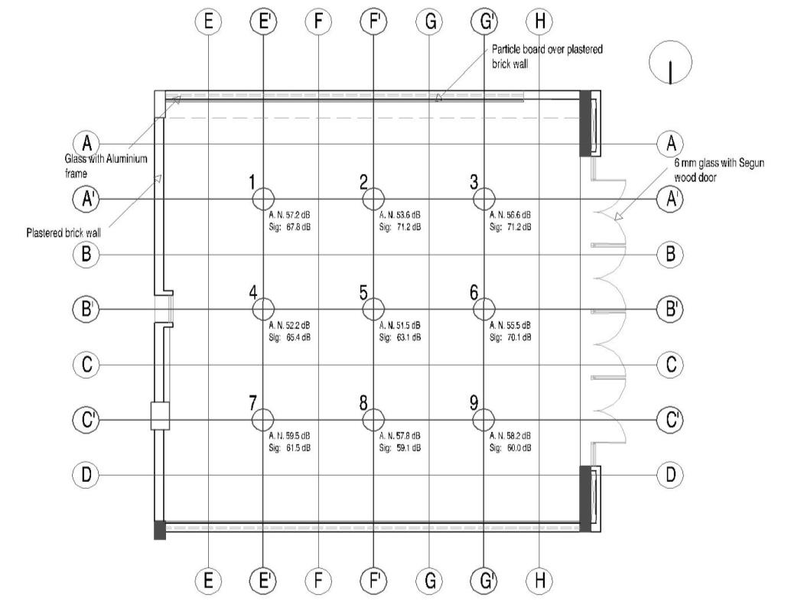
Figure 8: Floor Plan of the Case Jury Room Showing the Location Points and
Ambient Noise and Signal Values
Ambient noise and signal at 9 selected location points, shown in Figure 8 were measured by the sound meter (Extech 407732: Low/High Range Sound Level Meter) in the vacant case room.
Table 2: Calculation of SNR for the Case Jury Room
Location Points | Ambient Noise (A.N.) In Vacant Room  (Db) | Ambient Noise After Participating 19 Students  (Db) | Signal After Participating 19 Students  (Db) | Expected Ambient Noise (Considering 75 Visitors)  (Db) | Expected Signal (Considering 75 Visitors)  (Db) | Signal-To-Noise Ratio (SNR) Expected Signal- A.N. (Db)
1 | 51.1 | 53.5 | 61.7 | 57.2 | 67.8 | 10.6
2 | 47.5 | 50.2 | 65.1 | 53.6 | 71.2 | 17.6
3 | 50.5 | 51.9 | 65.1 | 56.6 | 71.2 | 14.6
4 | 46.1 | 46.7 | 59.3 | 52.2 | 65.4 | 13.2
5 | 45.4 | 47.5 | 57.0 | 51.5 | 63.1 | 11.6
6 | 49.4 | 52.0 | 64.0 | 55.5 | 70.1 | 14.6
7 | 53.4 | 54.8 | 55.4 | 59.5 | 61.5 | 2.0
8 | 51.7 | 50.6 | 53.0 | 57.8 | 59.1 | 1.3
9 | 52.1 | 54.6 | 53.9 | 58.2 | 60.0 | 1.8

After calculating the ambient noise in the vacant room, students took their positions in small groups at the same points in the room and started murmuring amongthemselves. Then the ambient noise values, keeping the students present were measured by the sound meter. According to Table 2, location point, 7 provided the highest value of 54.8 dB, while the location point 4 gave the lowest ambient noise value. Then a participant stood between the presentation perimeter and read a sentence in Bengali Language ‘Amar kotha kotota jore shona jay, sheta kheyal rakhun’ at a frequency of 700 Hz to 850 Hz and signals were measured at the same points. Finally, the values were converted considering 75 numbers of occupants in the case jury room. Literature shows that, the average 1.6 dB ambient noise increases in the participation of each extra audience. Therefore, considering 75 visitors, the expected ambient noise will be +6.1 dB higher than the reported values by 19 occupants during jury session.
According to BNBC, there shall not be a difference greater than 6 dB between sound pressure level of any two points in this case. However, in the jury room, the maximum difference between signal and ambient noise was found12.1 dB. Therefore, it is predictable through the survey that, the values differ in a greater scale from the front row to the rear row and the speaker has to raise his voice so that the audience from the back row can hear, which will create hearing disturbance for the front rows due to loud voice. On the other hand, for speech halls with higher background noise (>20 dB), the recommended SNR is at least +6 dB for adults (BNBC, 2015). Here, the SNR values differ tremendously from the first row to the rear row in the case room. Audience from the front row (1,2,3 points) will be able to get a clear lecture from the presenter and jurors. However, due to lower SNR values of 7,8,9 points shown in Table 2, the speech intelligibility was found in a very poor condition in the back row.
DISCUSSIONS AND RECOMMENDATIONS
The field survey result provides an unsatisfactory sonic environment in the case jury rooms, which determines the lack of concentration on acoustical design for the jury rooms in Dhaka. Therefore, a partial experiment was conducted in the case jury room, installing Painted Polystyrene, expanded on 50mm battens in the 16 among 64 numbers of voids on the waffle ceiling (Figure 9& Figure 10).
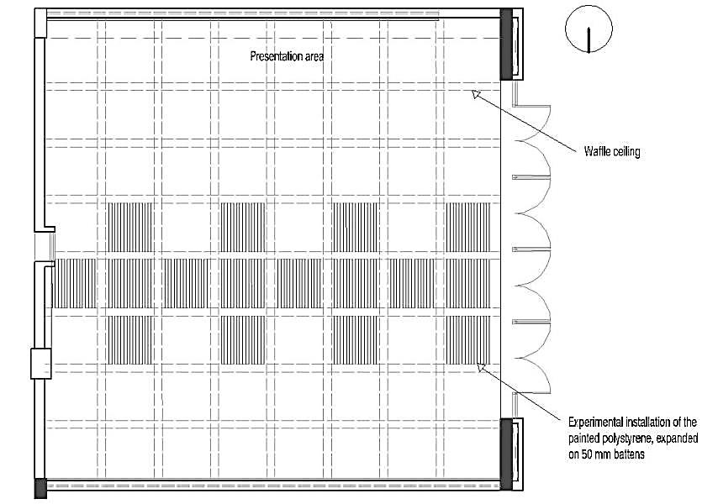
Figure 9: Floor Plan of the Case Jury Room Showing the Location of Vertical Polystyrene Panels
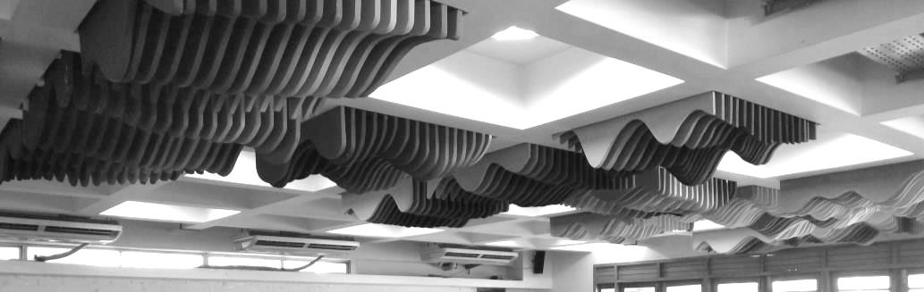
Figure 10: Interior View of the Case Jury Room Showing the Location of Vertical Polystyrene Panels
Polystyrene has a high Noise reduction coefficient (NRC) value of 0.35, which provides high absorption and diffusion of sound, creating lower RT. After installing the vertical polystyrene panels, the RT was calculated as follows,
Total absorption by the material properties in the existing case room was, 59.94 Sqm Sabins. After installing the panels, total absorption in the room was, 59.94+ (23.8 x 0.35)= 68.27 Sqm Sabins. Therefore, RT of Jury room after experimentation= 0.16 x 458.43/ 68.27 = 1.07s, which is acceptable for the English language. However, for satisfying the RT requirements for the Bengali language, the painted polystyrene can be installed in the remained voids. If the panels are installed, the RT will be as follows,
0.16 x 458.43/ {59.94+(95.16 x 0.35)} = 0.58 s, which is very recommendable for both English and Bengali language.
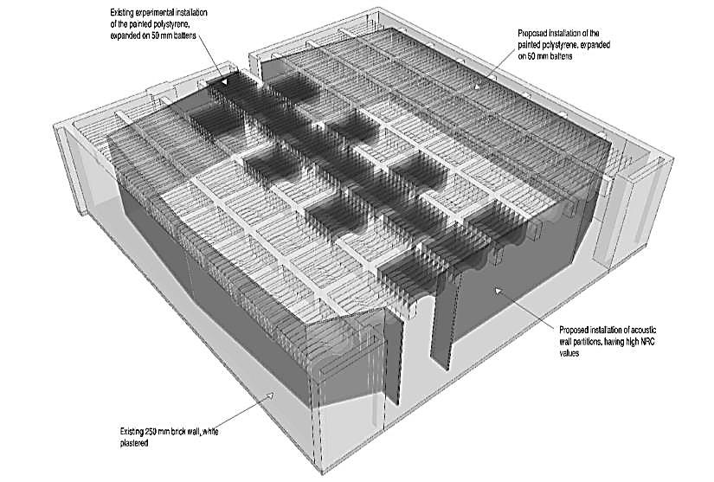
Figure 11: Axonomatic View of the Case Jury Room Showing the Proposed
Location of Ceiling and Wall Panels
In addition to the fixation of the ceiling panels, angular acoustic wall partitions can be installed, while straight or concave surfaces should be avoided (Figure 11). Concave ceilings and curved walls focus sound energy creating hot and dead spots. The primary goal is to minimize parallel, reflective paths between the surfaces in the room. Opposite and parallel plain surfaces can set up strong inner reflections. This is best accomplished with a combination of diffusive and absorptive treatments and these are easily applied to walls and ceilings (Wenger, 2000). Since all materials absorb sound preferentially, the aim should be to use them in such proportions that the resultant period of reverberation is correct at all frequencies (Muktadir, 2010). Moreover, Materials with high NRC value could be used as absorbing the material. For example Thermatex Thermofon has an NRC value of 0.85 and RH is up to 95%, while Thermatex Alpha 1 has an NRC value of 100 and RH up to 95% (Imam, 2009).
CONCLUSIONS
Designing jury rooms concerns very little in certain key acoustical properties. Therefore, acoustic quality assessments are needed to be necessary for identifying the problems and give guidance to provide the proper acoustical condition, evenly distributed everywhere in the space. The findings of this paper clearly indicate that carefully designed ceiling and walls for an acoustic solution plays as a prime factor for providing a satisfactory speech intelligibility condition in the jury rooms. Considering the time and resource constraint for the research, other built environment concerns, i.e. daylighting, aesthetics, thermal comfort, economics, glare control, ventilation, safety, security and subjective concerns of privacy and view of space were kept beyond the scope, which may be addressed by further studies. Finally, assessment of acoustic quality is expected to be useful for the acoustical design of the jury rooms not only in Bangladesh but also in the same tropical countries.
ACKNOWLEDGEMENT
The authors would like to thank the supervisor of Sonic Environment course: S.M. Najmul Imam, Professor, Department of Architecture, BUET, for his advice, guidance, suggestion, and support throughout the research. Moreover, they are also grateful to the Architecture departments of Bangladesh University of Science and Technology and Ahsanullah University of Science and Technology and student volunteers for helping to conduct the research successfully.
REFERENCES
- Aman, J. and Joarder, M.A.R. 2017. Performance evaluation of different window configurations to enhance effective daylighting in architecture design studios in Dhaka. Proceedings of the 1st international conference on green architecture. University of Engineering and Technology, Dhaka.
- Amasuomo, J. O. M. 2013. Speech Intelligibility And Good Sightline For Vision In Lecture Hall Acoustics as a Determinant for Effective Learning/Teaching Environment. V1,I11: International journal of scientific & technology research.
- Bradley, J.S. 1986. Predictors of speech intelligibility in rooms. J. Acoust. Soc. Am. 80: 837–45.
- De-Chiara, J. & Crossbie, M. J. 2001. Time-saver Standards for Building Types. 4th Edition. New-York: McGraw-Hill Book Company.

Imam, S. M. N.; Ahmed, N.; Takahashi, D. 2009.Effects of Reverberation Time on Percentage Syllable Articulation for Bangla Language. Journal of the Asiatic Society Bangladesh. 06/2009. 35(1):37-48.
- Kinsler, L. E; Frey, A. R.; Coppens, A. B & Sanders, J. U. 2000. Fundamentals of Acoustics. 4th Edition. New York: John Willey and Sons Inc.
- Pumnia, B. C; Jain, A. K & Jain, A. K. 2005. Building Construction. New- Delhi: Firewall Media.
- Bangladesh National Building Code (BNBC). 2015.Bangladesh National Building Code. Dhaka: Chapter 3, Part 8.
- Muktadir, M. A. 2010.. Designing buildings in the tropics with environmental technologies in Architecture. Dhaka, Bangladesh: AUST.

